**Appendix 01.1: Example process and description of the tasks**

1. **Example flowchart**

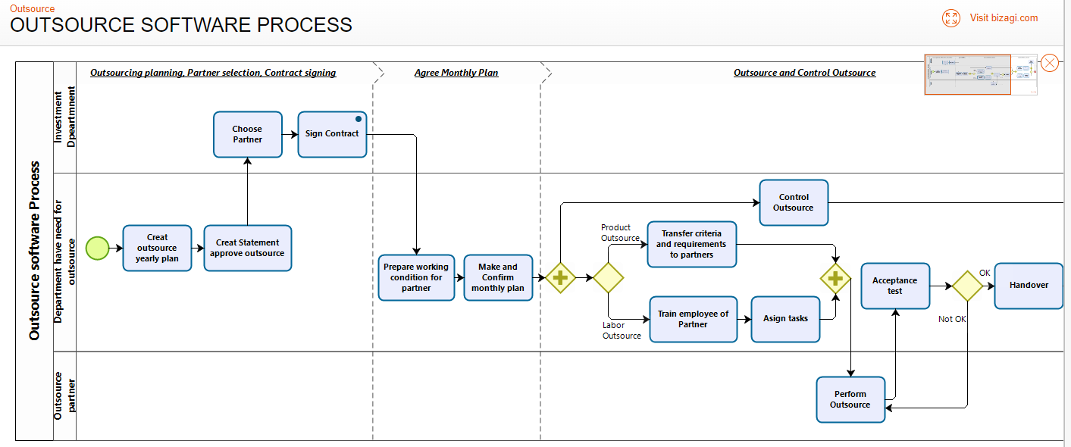

1. **Required fields for each Task**

